6.Create a simple cloud software application for Payroll Processing System using any Cloud Service Provider to demonstrate SaaS include the necessary fields such as Name of the [1]employee, experience in present org , over all experience, basic pay, HRA, DA, TA, net pay, gross pay etc.

STEP1:

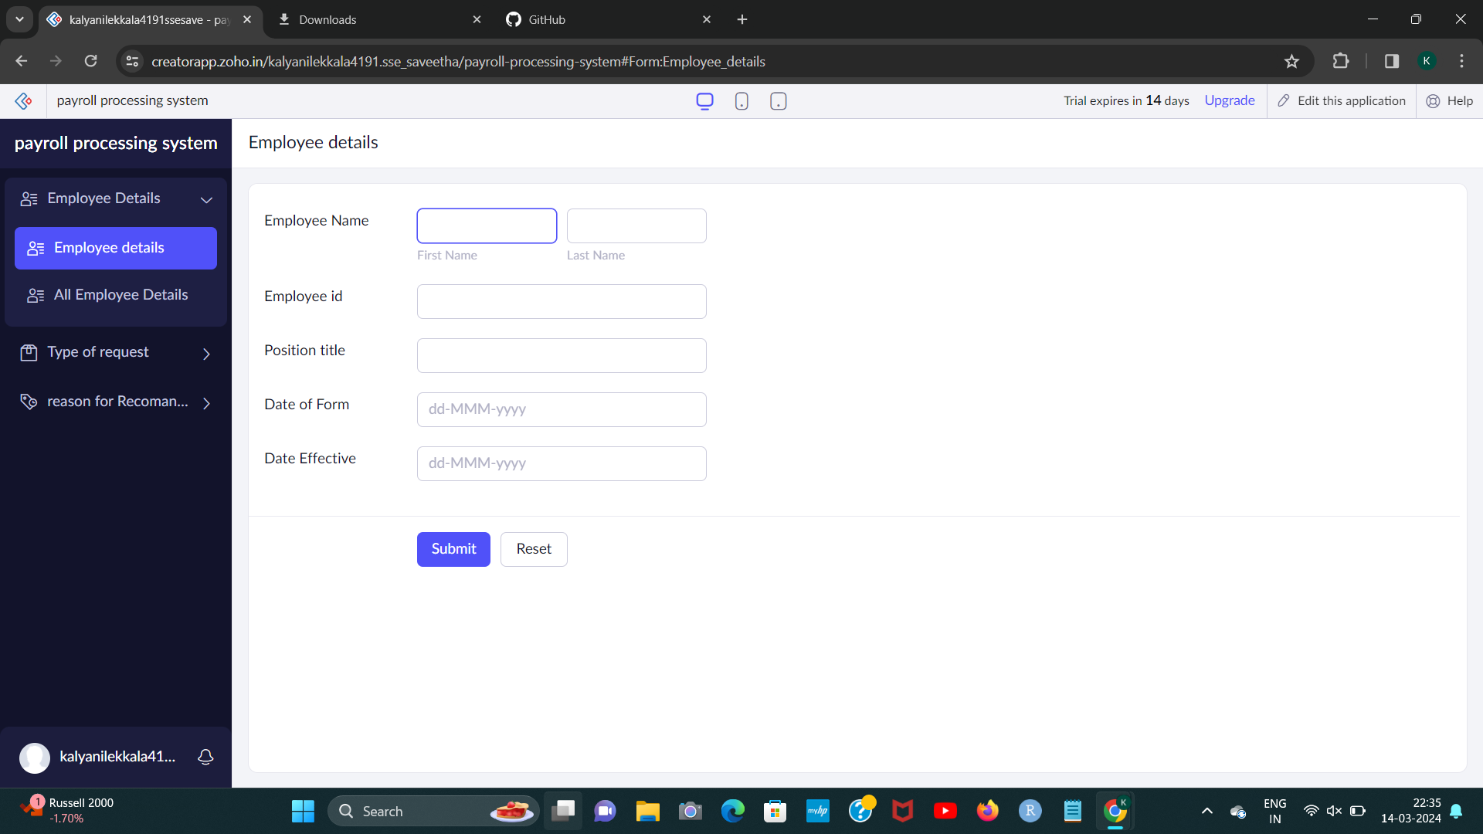

STEP2:

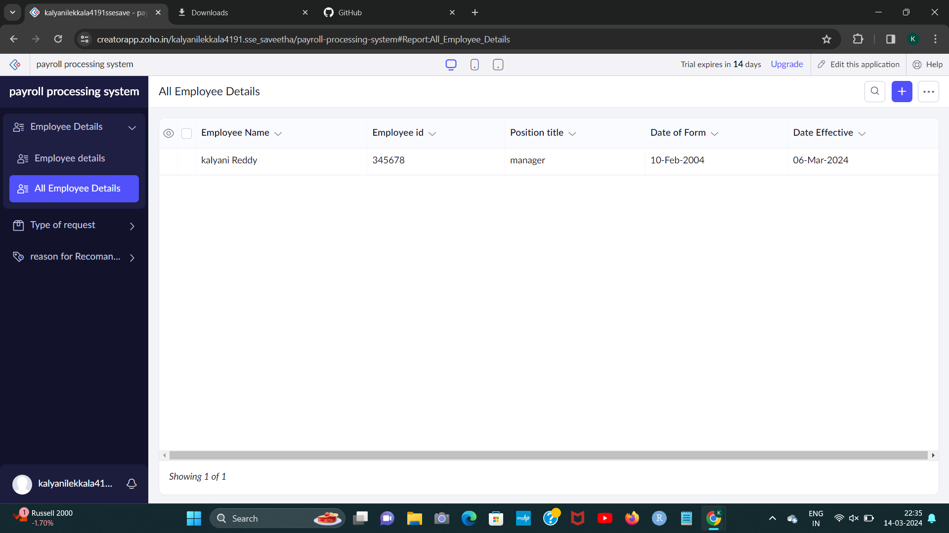

STEP3:

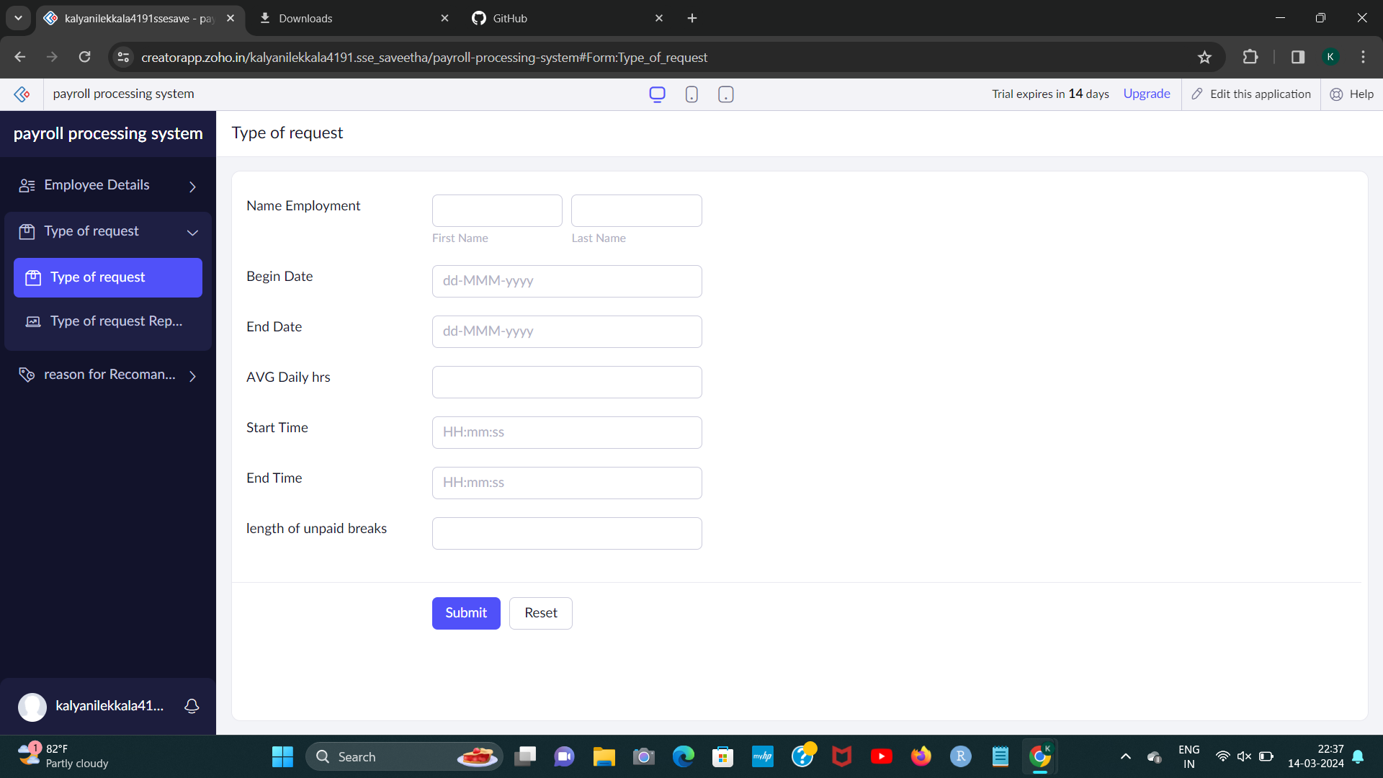STEP4:

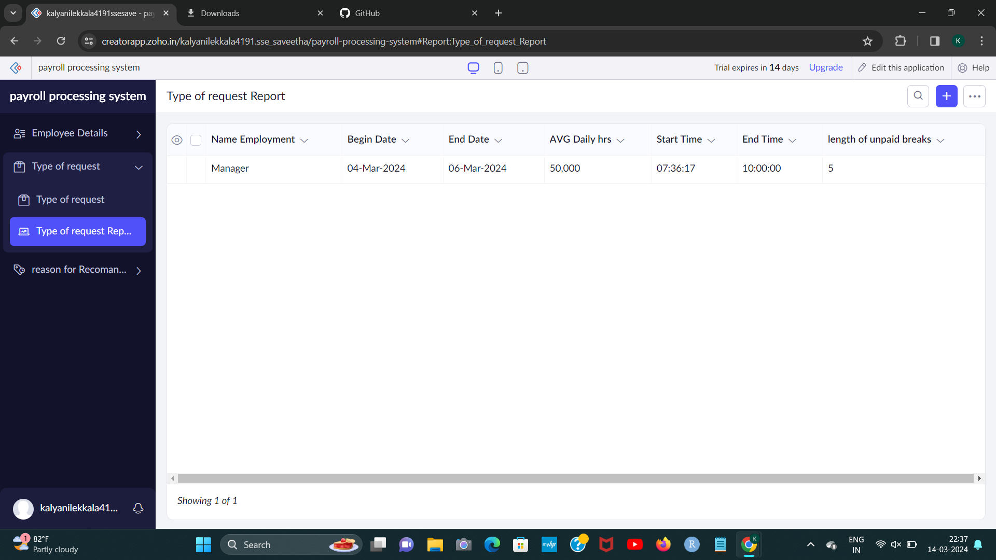

192224191 L.Kalyani

STEP5:

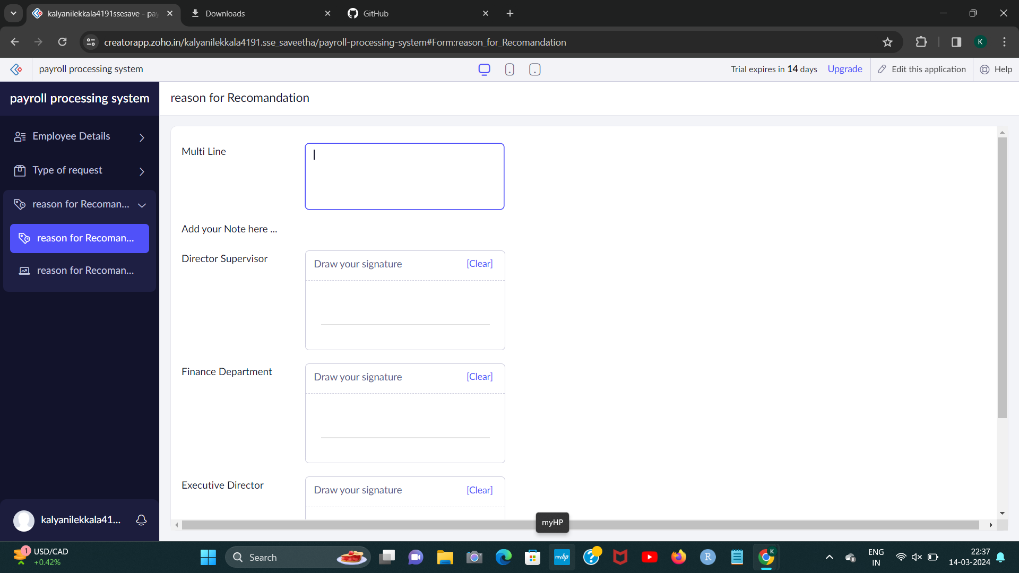

STEP6:

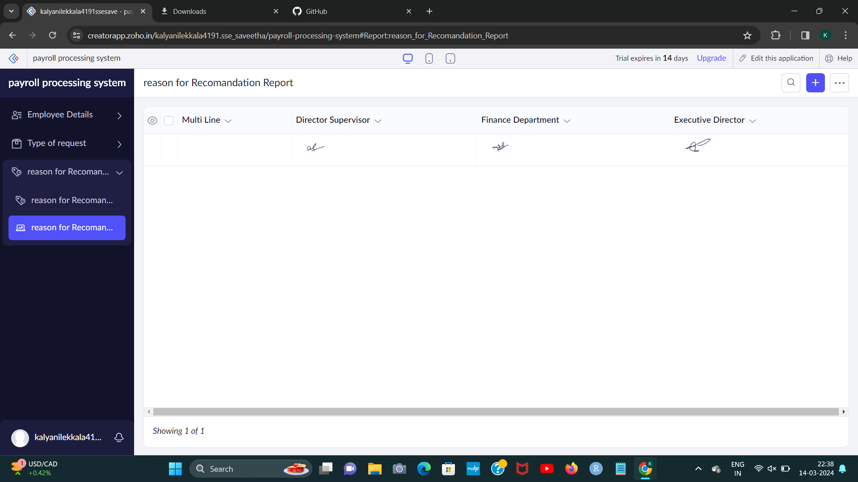[2]

1. 192224191 L.Kalyani
2. 192224191 L.Kalyani